|  |  |  |  |  |
| --- | --- | --- | --- | --- |
| Description: EGC_Black | | Mathematics Essentials 2016  Unit 3/4 Test 1  Task Weighting: 6% | | |
| Student Name: |  | |  |

Time Allowed: 55 Minutes Total Marks: 52

**Calculators and files are allowed in this test.**

***Answer all of the following questions. Show all working where appropriate to maximise marks.***

### Question 1 (5 marks)

**Circle** the correct answer to each of the following:

a) 2.15 km converts into how many metres?

(i) 21.5 m (ii) 215 m (iii) 2150 m (iv) 21500 m

b) 250 L converts to how many ml?

(i) 250 ml (ii) 2500 ml (iii) 0.25 ml (iv) 250000 ml

c) 1 m2 converts to how many cm2?

(i) 100 cm2 (ii) 10 000 cm2  (iii) 100 000 cm2 (iv) none of these

d) 5.4 cm2 converts to how many mm2?

(i) 540 mm2  (ii) 5400 mm2 (iii) 54 mm2 (iv) none of these

e) 15 m3 has a capacity of how many Litres?

(i) 1500 ml (ii) 15 L (iii) 15 000 L (iv) 150 000 ml

**Question 2 (3 Marks)**

Find the shaded area. Give your answer to one decimal place.



Question 3 (12 marks)

|  |  |  |
| --- | --- | --- |
| **Name each Shape** | Volume | Surface Area |
| **Name:** |  |  |
| **Name:** |  |  |
| **Name:** |  |  |

### Question 4 (2 marks)

### What is the capacity of the third shape in Q3

### Question 5 (7 marks – 3, 2, 2)

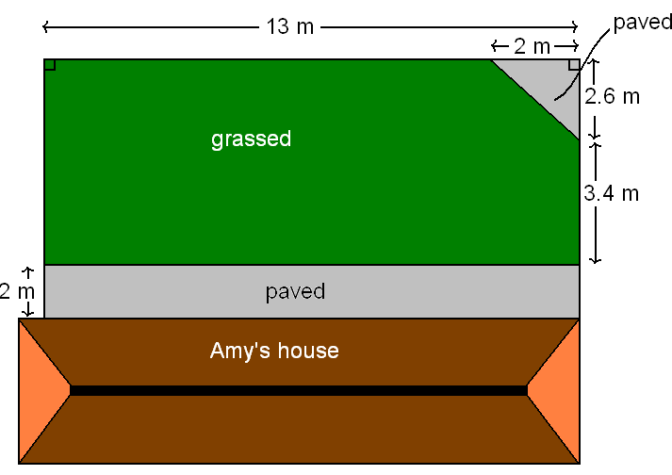Here are the plans for Amy’s backyard. She wishes to pave part of it and have grass for the rest.

**a)** What is the total area of the paved sections?

**b)** What is the total area of the grassed region?

**c)** Amy wants to fence her back yard (not including the distance along the house). Calculate the total length to be fenced.

**Question 6 (3 marks)**

Calculate the perimeter of the shape below:

6.5 m

**Question 7 (6 Marks – 2, 1, 3)**

A bike has wheels that are 66.5 cm in diameter.

(a) How far does the bike move **(to the nearest centimetre)** in one full turn of the wheel?

(b) How far would the bike move after 30 turns of the wheel?

(c) How many turns would it take to travel three kilometres

### Question 8 (5 Marks – 3, 2)

a) Find the surface area of this box to the nearest cm2

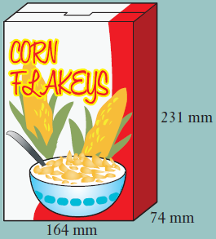

b) Find the volume of this box correct to the nearest cubic centimetre.

**Question 9 (5 marks – 3, 2)**

A **choctop cone** is a favourite with movie-goers. The cone is full of ice-cream and has a scoop of ice-cream on top in the shape of a hemisphere which is covered in chocolate as shown below.

1. What is the total volume of ice-cream? (Round answer to one decimal place)

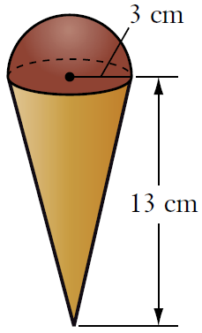

* 1. What surface area is covered with chocolate? (Round answer to nearest whole number)

**Question 10** **(4 marks – 2, 2)**

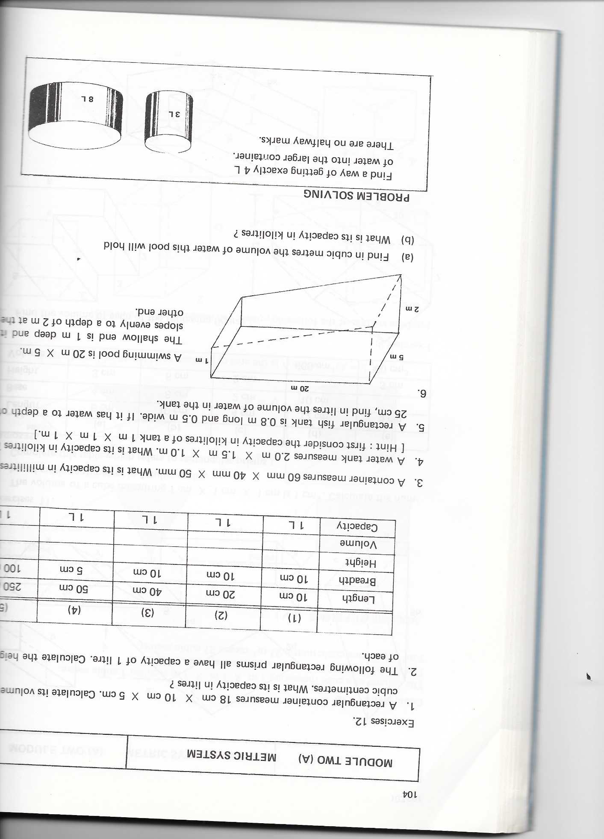

A swimming pool is 20 m X 5 m. The shallow end is

1 m deep and it slopes evenly to a depth of 2 m at

the other end.

1. Find in cubic metres the volume of water this pool will hold.
2. What is it’s capacity in kilolitres?

**END OF TEST**